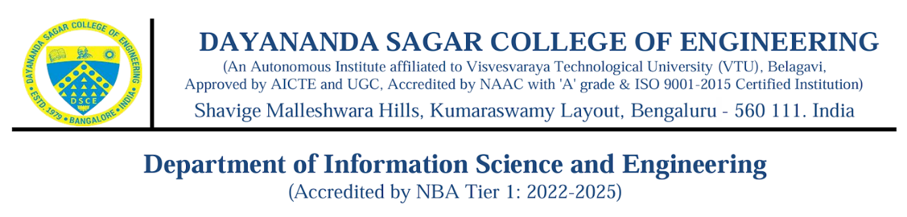
DSCE ISE ACM Student Chapter 2026
Established on 1st October 2018
ACM Co-ordinators:
Sl. No. | ACM Membership - ID | Name
 | 14523314 | Dr.Rajeshwari J
 | 1733196 | Mrs. Shalini K B
 | 5443321 | Mr. Bharath B C
 | 14528901 | Mrs. Vidya G Byakod

ACM Faculty Details:
Sl. No. | ACM Membership - ID | Name
 | 14523287 | Dr. Annapurna P Patil
 | 9643993 | Dr.Chandrakala B M
 | 7900183 | Dr. Muzameel Ahmed
 | 14262289 | Dr. Latha Anuj
 | 14527775 | Dr. Prathima Mabel J
 | 14527863 | Vijetha
 | 14528917 | Madhavaram Swapna
 | 14529707 | Vani Dixit
 | 14528939 | Monicashree M
 | 4141132 | Spoorthi M
 | 14530657 | Sai S Joshi
 | 14528945 | Girija R
 | 1615085 | Kusumika Dutta
 | 1635565 | Samitha Khaiyum
 | 682217 | Pavithra Shetty
 | 3839328 | Raksha Kodnad R
 | 9433981 | Seema Aparaj
ACM Student Details:
SL No. | ACM Membership ID | Name
 | 9560746 | Praveen A
 | 1746068 | Aman Agarwal
 | 9227784 | Khushi Agrawal
 | 2772303 | Sreevidya B S
 | 1733196 | Pavani B V
 | 2345870 | Shimsha Bhagavandas
 | 6077352 | Deepshree Buchade
 | 576047 | Ankita C
 | 3878948 | Karthik Devadiga
 | 6946533 | Niveditha G N
 | 6998053 | Madhumitha H
 | 3611502 | Shreyas Hegde
 | 3958155 | Prathamesh Hiremath
 | 3881235 | Anurag Jain
 | 7046026 | Prajin Jain
 | 9753830 | Ayush Kashyap
 | 3882101 | Prathiksha Kesari
 | 7229054 | Vidya Kumari
 | 455941 | Manaswini Kv
 | 119936 | Aruna Mg
 | 653060 | Krupa N
 | 8077632 | Pallavi N
 | 773276 | Sinchana O S
 | 4443868 | Arpit Ravi
 | 3762035 | Reshma S
 | 6520410 | Pavitra Savant
 | 6449793 | Mohammed Shaiz
 | 1443815 | Ananya Shastry
 | 3081764 | Aditya Shome
 | 9482379 | Prakruthi T
 | 8205740 | Gautham Krishna Vijayan
 | 6126891 | Anupama Vijaykumar
 | 0135490 | Mr. Arjun Paartha

